Big Mountain Resort Report

Big Mountain Resort has recently installed an additional chair lift to help increase the distribution of visitors across the mountain. Unfortunately, this extra chair increases their operating costs by $1,540,000 over this upcoming ski season. Upon looking at the different ticket pricing from Big Mountain and its competitors, we determined that predicting the Adult Weekend Ticket price was the primary goal. After looking at geographical differences, we found that the state where a resort resided had no direct or obvious correlation to ticket pricing. Thus, we looked at what features were in demand by customers and what they were willing to pay for them.

When we modeled different resort features, we determined that 'fast quads,' the number of runs, snowmaking per average, and vertical drop are all features customers were willing to pay a premium.

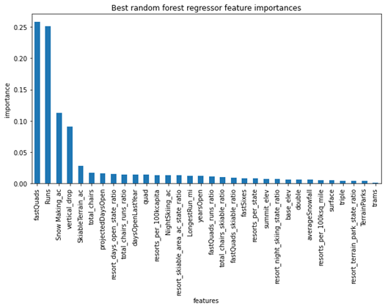

The current price for Adult Weekend Ticket at Big Mountain is $81. The model price came out to be $95.87 with an MAE of $10.37, which shows room for a price increase.

Management also shortlisted some other options they were considering to either raise ticket prices or cut costs. Some of these include: Permanently closing down up to 10 of the least used runs. Increase the vertical drop by adding a run to a point 150 feet lower down but requiring the installation of an additional chair lift to bring skiers back up without additional snow-making coverage, having the same improvements as number 2 but adding 2 acres of snow making cover. And finally, increase the longest run by 0.2 miles to boast 3.5 miles length, requiring additional snow-making coverage of 4 acres. We found that closing one run made no appreciable difference in modeled ticket pricing when looking to close runs to save operating costs. Closing 2 and 3 successively reduces support for ticket price and so revenue. If Big Mountain closes down three runs, they can close down up to 5 as there's no further loss in the ticket price. On the other hand, if they were to increase the closures to 6 or more runs, it would lead to a significant drop.

Our final recommendation is for Big Mountain to add a run, increase the vertical drop by 150 feet, and install an additional chair lift, it would increase support for ticket price by $1.99. Over the season, this could be expected to amount to $3,474,638 in additional revenue. The other suggestions in the shortlist would add nothing to the modeled price and therefore are not recommended.